IMPERIAL HEAVY STRONGHOLD - draft
(all activation at 2+) – Scenario only. Estimated points value: 2.500
http://eatotalwar.forumfree.it/?t=65993267#lastpost
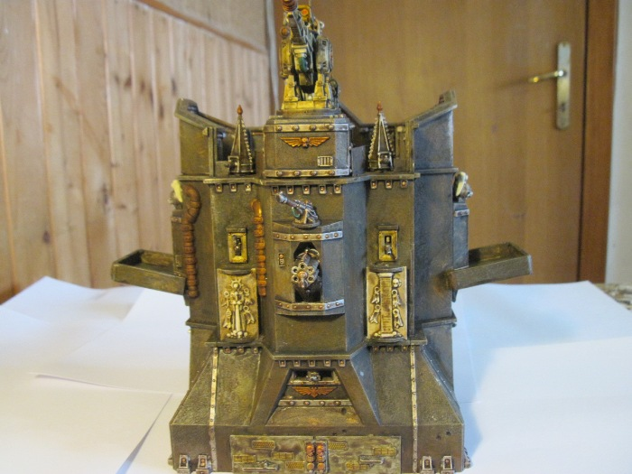
The imperial heavy stronghold consist of 3 different detachment, so 3 different activations, inserted inside the Stronghold building:
- The short range defence system
- The heavy defence system
- The void shields generator system
Each of them are warengine, about fire is considered in cover, and have 6 damage capacity, armour 4+ reinforced, tick rear armour, fearless. The critical effect destroy the single system
Short range defence system
The short range defence system can fire all round, measuring from each of the 4 stronghold side, all his firepower.
12X HEAVY BOLTER: 30cm AP5+
6X LASCANNON: 45cm AT5+
4X BATTLECANNON: 75cm AP4+/AT4+
Heavy defence system
The heavy defence system can fire in this way:
SIDE OF THE GATE*:
1X HELLSTORM CANNON as per Emperor Titan
1X DEFENCE LASER as per Emperor Titan. The AA ability is at 360°all around
OPPOSITE SIDE OF THE GATE*:
1X QUAKE CANNON as per Emperor Titan
ALL AROUND*:
1X PLASMA ANNIHILATOR as per Emperor Titan
*Is possible split fire against two different detachment respection the fire arc and the side of the weapon system.
Void shield generator system
The void shield generator system protect the building itself and the 3 weapon system with 12 void shield. Can do only the order reorganize, for remove fire or repair void shield as usual. When this order is done don’t affect with -1 penality the weapon system.
THE STRONGHOLD.
The stronghold have:
DC: 40, armour 4+ reinforced, and can be hit only by marcoweapon and titan killer weapon and barrage: the barrage point number is the number of attack that it receive. In addition can be damaged in engage directly only be war engine.
CRITICAL: 1 point less of Damage Capacity and 1D3-1 unit inside must make a save of the same quality that have hit the building, choosen by the “heavy stronghold player”
The balcony and the roof.
In the balcony and the roof can be stored some stands. All the stand can be engaged only by skimmer unit, and can’t engage the enemy bottom. All the company on the roof can fire outside all their firepower measuring from any side of the heavy stronghold. All the unit are considered in cover, like a building 4+ cover save. The company on the roof is immune at the 1st fire to be under enemy fire for the massive protection of the heavy stronghold, disrupt fire is devided per 2 rounded down.
The gate and transport ability.
Titan or warengine from DC 4 or more can’t enter inside the stronghold.
The stronghold can transport 1 heavy tank/super heavy tank company/mechanized infantry detachment and 3 infantry detachment (without any kind of vehicles), plus 4 support detachment. The infantry, only infantry detachment can move outside through the gate or upon the roof, with an order that provide at least one movement. The heavy tank/super heavy tank company/mechanized infantry detachment and the support not completely composed by infantry must if they want go outside only through the gate. The gate can open and close at players will.
All the company stored inside the Heavy Stronghold can’t be reached by any kind of fire.
THE GATE have 4 DC, 4+ reinforced armour, tick rear armour, fearless and is treated as a common warengine.
The detachment stored inside the fortress can’t be engaged UNTIL the gate are destroyed.
If the gate is destroyed and happen an engage, the engager can invade the fortress with:
- amoured/vehicles/mounted and engage only the 1 heavy tank/super heavy tank company/mechanized infantry detachment AND/OR, as his choice, from 1 to 4 support detachment supposed inside.
- all infantry composed detachment and engage every unit he want, conquering the stronghold.
For represent the peril of been engaged inside the stronghold the engager will fight the engage with his best value, firefight or close combat as he want, and the engaged must answer with this value. Put in contact the unit one to one with all the enemy unit of one or more detachment, and double it as the EA classic rule if exceed, the engager choose how much detachment engage. All the detachment transported inside is considered mixed for the engage general rule. Don’t exist support fire, can use the firefight value only the detachment engaged. In additional, the engager at the resolution of the engage have a +1 bonus modifier. This represent that been engaged inside the fortress is a disaster for the defender.
Only exception to this rule is the unit on the roof/balcony. If there are unit transported, the engager can only engage, if he haven’t jump pack or skimmer, first the detachment transported. And in a second turn the company on the roof. Own or opposite unit inside transported on the heavy stronghold can’t support any engage.
If the engager win he can do his 5cm movement inside the fortress, ONLY if inside there is no unit transported, the company on the roof/balcony is not “transported”, but is outside for all the purpose. If there are still one or more unit transported, he must move outside the fortress, near the gate.
Fire at the Heavy Stronghold, at the defence system or at the units on the roof/balcony or the gate.
When the heavy stronghold, the defence systems, the gate or the units on the roof/balcony are under fire, if still exist any void shields, the void shields absorbe the fire, without any effect. Don’t put the fire at the possible target (I remember here that the Heavy Stronghold itself is a building and can’t fall back). If the voild shield collapse and finally hit, or where just collapsed, so procede with the fire attack as usual. The general rule is this, everything that will not is the Heavy stronghold itself is considered in cover, so -1 to hit.
BUT
Each attack to the defence system/troops on balcony-roof/gate that CAN damage the building will do without the -1 penality.
An example for all: I fire with advance order with a shadowsword: 2 attack AP5+ and 1 volcano cannon to the units on the roof. So, the two attack AP5+ will hit at 6 the infantry, and will not damage the heavy stronghold. The volcano cannon that usually hit at 2+; will hit at 3+ the infantry in cover, and at 2+ the stronghold, damaging it. Don’t roll two dice. Roll one dice, and see the value. If you roll 3 or more you have hit the unit and damaged the building too, if you roll 2, you have damaged only the building, if you roll 1, you miss everything.

