Blank Campaign Map
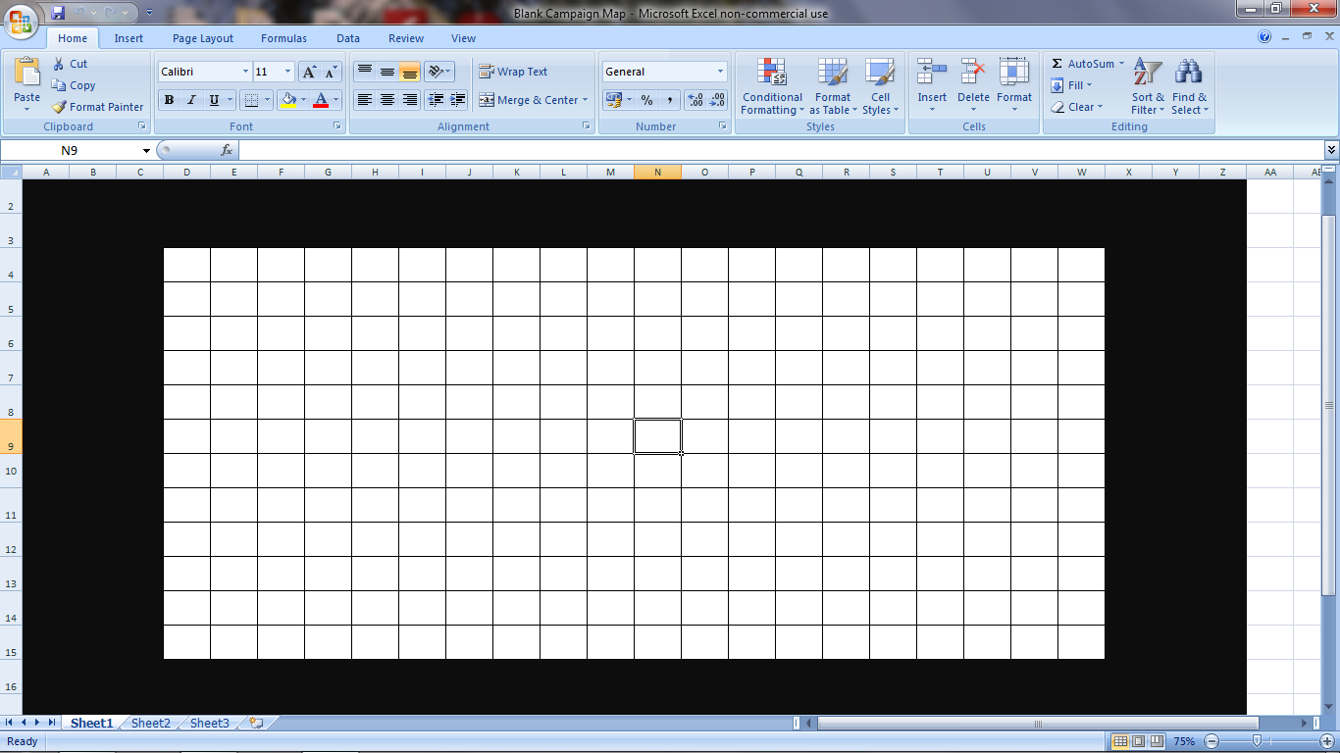

Example of Campaign Map (See rules for colour key):
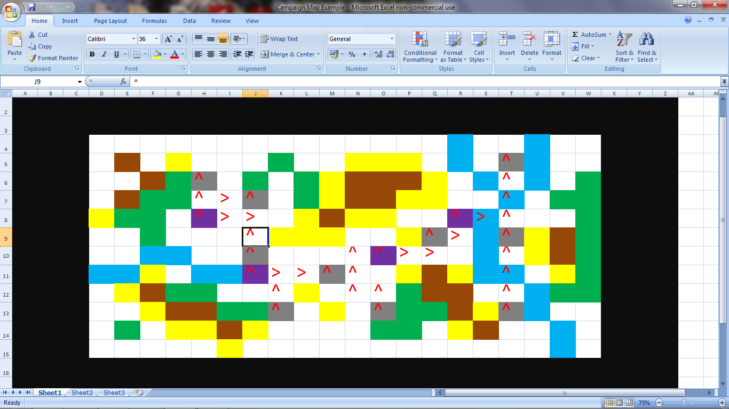
Yes I know it looks like a rotten piece of modern art!

Example of Campaign Roster (part one)


