New England 1.2 Elysian Experimental List vs. Black Legion Battle Report
This game set my Elysian Drop Troops against Kal’s Black Legion during Historicon 2022. Kal is a regular Epic player who historically runs Epic tournaments in the Mid-Atlantic region of the US. He agreed to play the experimental Elysian Drop Troop list during some free time at the convention, offering some additional insight and recommendations to continue the Elysian’s development.

Army Compositions:

Elysians:

Black Legion:
- Daemon Pool (Chaos Undivided), 6x Lesser Daemon – 90 pts
- Retinue, 8x Chaos Space Marines (Chaos Undivided), Chaos Lord, Daemonic Pact Obliterator, Dreadclaw Drop Pod – 380 pts
- Retinue, 8x Chaos Space Marines (Chaos Undivided), Chaos Warlord (Supreme Commander) Daemonic Pact, 4x Rhino – 390 pts
- Armored Company (Chaos Undivided), 4x Chaos Predator 3x Chaos Vindicator – 305 pts
- Chaos Terminators (Chaos Undivided), 4x Chaos Terminators Chaos Lord – 275 pts
- Chosen, 4x Chaos Space Marine Scouts (Chaos Undivided), Daemonic Pact, Dreadclaw Drop Pod – 155 pts
- Raptor Cult (Chaos Undivided), Chaos Lord, 6x Raptor Daemonic Pact – 270 pts
- Havoc Retinue (Chaos Undivided), 4x Havoc Units, Chaos Lord, 2x Rhinos – 225 pts
- Hell Blades (Chaos Undivided), 3x Hell Blade Fighters – 200 pts
- Devastation Class Cruiser – 150 pts
- Death Wheel Squadron, 1x Deathwheel – 275 pts
- Death Wheel Squadron, 1x Deathwheel – 275 pts

Set-Up:

Interestingly, this game saw two planetfall heavy armies playing against each other with the majority of each’s heaviest formations held in reserve. The Elysian’s also maintain a marked advantage in airpower with four flyer formations consisting of seven total aircraft to Kal’s single formation of three Hellblades and no anti-aircraft units.

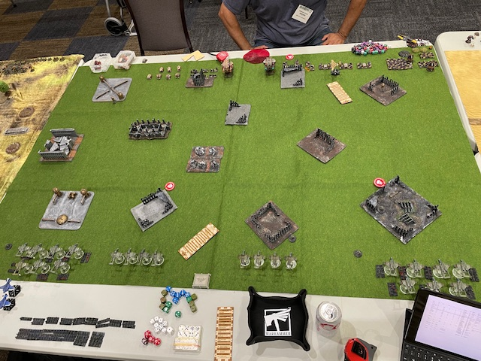
Game Set-Up

Turn One:

The first turn saw the Elysian’s begin to push aggressively on the far left and right flanks. The 1st Sentinel Squadron marches, using the intervening building to avoid retaliatory fire. Valkyrie Squadron 1 shifted left, preparing to counter the inevitable Doomwheel, and fired their complement of missiles at the Chaos Armored Company, destroying four and breaking the rest. The 1st Air Assault Company also shifted left in preparation for enemy drops and to avoid any cruiser strikes focusing on my Blitz objective. The Chaos Raptors also advanced on the Elysian’s left flank, taking cover in ruins.
The Doomwheels move down the center of the table, knocking out a Vulture from Valkyrie Squadron 2 before the fliers can shift towards the right objective along with the 2nd Sentinel Squadron. The 2nd Air Assault Company march towards the far right-flank objective on Kal’s half of the table, dismounting and attempting to maximize cover where able. One Chaos retinue also shifts towards the same objective.
The air war also kicks off in earnest. The Hellblades drop their Firestorm payload on the dismounted 2nd Air Assault Company, rolling over 12x cover-ignoring hits. Disastrously, only a single stand of Elysians are killed. The Elysian’s respond by intercepting the Chaos flyers, killing one flyer. The Marauder Vigilant called in the 3BP MW attack on the centerfield Chaos retinues causing minimal damage with the remaining Thunderbolts harassing the Chaos retinues.

In the end phase, the majority of units were able to remove their blast markers with the critical exception of the Chaos Armored Company.

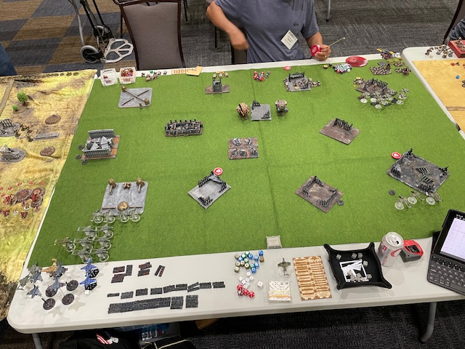
End of Turn 1

Turn 2:

Chaos preparatory bombardments fail to hit imperial forces but Dreadclaws and Terminators begin to saturate the Imperial side of the table. Chaos Chosen land around the left objective marker on the Imperial side of the table and are reinforced by demons. The largest Chaose retinue drops closer to the right objective on the Imperial side of the table with the terminators materializing close to the Imperial back-right corner. These Chaose units proceed to assault and destroy both the 2nd Vulture and Sentinel Squadrons with the retinue suffering a couple casualties in return.
On the Chaos’ side of the table, the 2nd Air Assault Company continues advancing and engages the Chaos Obliterators, destroying them and securing the far right objective. The second Doomwheel diverts attention to the air assault company, causing multiple casualties.
On the left flank, the 1st Sentinel Squadron marches onto the far objective on Chaos’ side of the table, gaining the Doomwheel’s attention. After a short burst of fire, the sentinels break and fall back to the corner out of line of sight. The 1st Air Assault Company counterattacks with the 1st Vulture Squadron managing to destroy the chosen and their demon allies.
The Imperial air power advantage proved decisive this turn. Thunderbolts finished the Chaos Armored Company, destroyed the remaining Hellblades, and continued to harass the Chaos retinues in the center of the table in preparation for the Elysian air drops next turn.

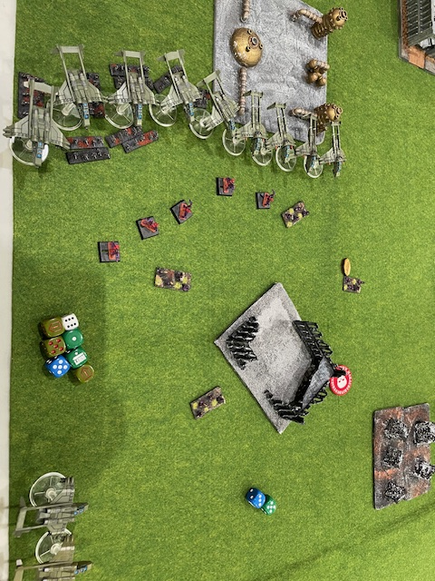
Elysian Counterattacks

Turn 3:

Both reinforced companies of Elysian drop troops self-planetfall in the rear-right portion of the table, providing much needed relief to the badly diminished 2nd Air Assault Company. The 1st Drop Troop Company assaults the center table Chaos Supreme Commander retinue, destroying the remaining Chaos forces and consolidate into the ruins. After the second Doomwheel breaks the 2nd Air Assault Company, the 2nd Drop Troop Company advances into the recently vacated ruins around the objective, focusing fire on the war engine causing blast markers.
The large Chaos retinue in the center of the table advance towards the Imperial Blitz objective with the badly mauled 1st Air Assault also advancing to contest. The 1st Vulture Squadron fires on the Doomwheel on the Imperial left flank causing minimal damage. In return, the Doomwheel and Raptors advance, wiping out the Vultures. The 1st Sentinel Squadron, after rallying in Turn 2’s end phase, advance and secure the far left objective on the Chaos side.
In a tense barrage of fire, concentrated bomber and fighter fire manage to destroy the Terminators holding the right objective on the Imperial side of the table. Additional fighter support manage to break then destroy the Doomwheel on the right side of the table. The game ends with a 3-0 Imperial victor for completing the Blitzkrieg, Break Their Spirit, and Take and Hold objectives.

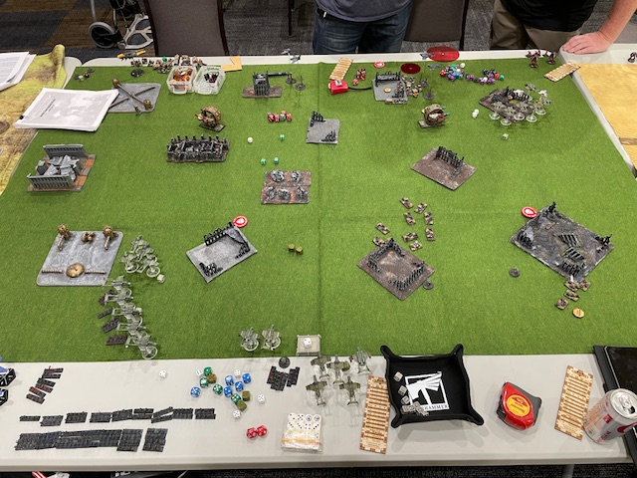
Final Assaults

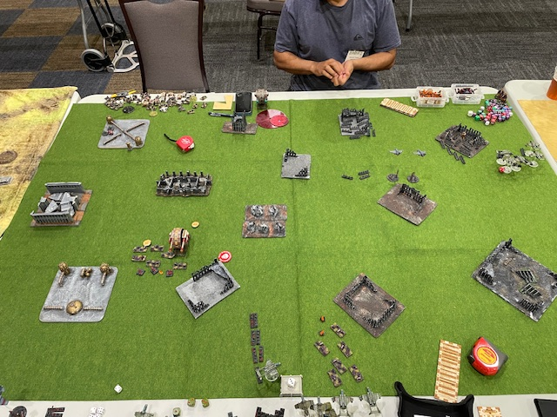
Endgame

Elysian List Thoughts:
Kal: Great game; was fun and challenging playing with a lot of units dropping throughout the game. Some suggested thoughts as the list continues development:
- Cost of Valkryies - upping the cost to take them since they seem pretty cheap for what their capabilities are.
- Limiting the number of self-planetfall formations. Maybe drop from 20 units to 10-12 units..
- Alternatively, have self-planetfall units have them pay for the ability, like 50 points per formation, instead of it being free.
- Also limit self-planetfall to say 1 self planetfall formation per 1000 points.
- The Marauder Vigilant was very expensive for what it could do

Some of this might bring the list to be more balanced. You seemed to have a good amount of formations and they all had a purpose. I would try different configurations to see how the list plays while playtesting.

Andrew: Overall this game further reinforces observations in the first battle report, namely that Valkyrie formations are too cheap, the single-plane bomber formations need points adjustments, and aircraft need different roles. This lists ability to drop a massive number of troops in the late game require some tempering as Kal highlights with a couple different options. Saying that, I believe the the games outcome was further exaggerated by the Elysian list being a pretty hard counter to Kal’s. The Chaos force was much smaller to the massive Elysian formations and lack of Chaos air power or defense gave my aircraft almost free reign of the field. This game was very different than fighting mass armor found in Minervan armies or Nidzilla builds (the Batrep to follow). Regardless it was a fun and challenging game with the Elysian’s having the list and table flexibility to play exactly how I’d imagine a highly mobile and ‘elite’ guard army to play while brutally punishing missteps.

To deep dive a little on suggested edits:
- For infantry companies make them twelve total infantry formations but maintain current point values; this helps balance the points issue
- Increase Company Transport upgrade to 150 pts for 6x Valkyries
- To make Valkyrie update more accessible, make single Valkyrie upgrades 25 pts for rocket pods, 25 pts for 2x twin lascannons (essentially the Vanaheim Vendetta Pattern stats), or 50 pts for 2x Hellstrikes
- Make Self-Planetfall a compulsory 50 pts upgrade for non-Valkyrie infantry companies; this tampers down the ability to load up on 30x paratrooper formations that could still be possible with alternative mitigations without making the formation unplayable. To be useful, Elysian paratroops need mass (numbers) to make up for their fragility. This is also fluffy for Elysians and paratroopers in general
- Veterans are too expensive; recommend dropping to 200 pts
- For aircraft adjustment, see my earlier battle report
- For character adjustments, see earlier battle report

