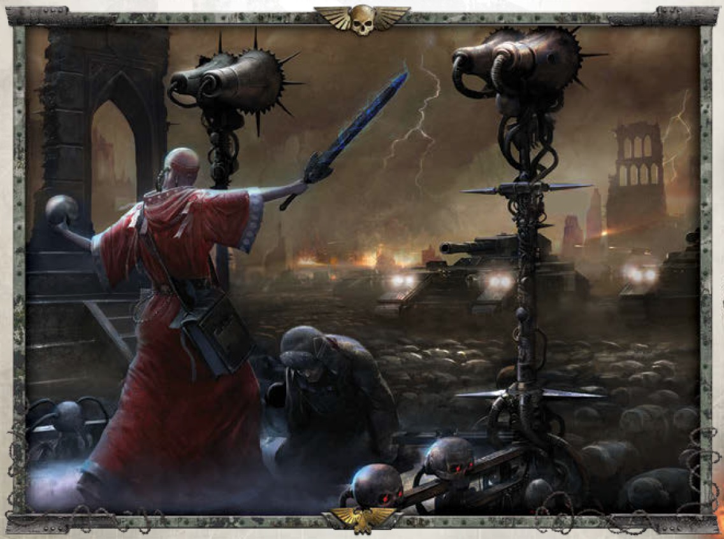

VALHALLAN IMPERIAL GUARD FORCE
The Ice Warriors are stoic and unwavering when on the defensive, resolutely holding their ground against fearful odds where other troops would consider it a good idea to flee. Enemies have often found that Valhallan defending forces need to be completely destroyed to capture the held ground. Valhallans are trained to fight in dense formations to support their morale. When on the offensive, Valhallans combine massed artillery barrages and infantry wave assaults. The morale of regiments is often backed up by attached Ministorum Priests.

Armageddon Valhallan Imperial Guard armies may be supported by Imperial Navy aircraft and Titan Legion battlegroups. A maximum of up to a third of the points available to the army may be spent on these formations.

Commissars
An Imperial Guard army may include one Commissar character per 500 points, or part thereof, in the army. The Commissars do not cost any points.
Commissar units may be added to the army at the start of the battle before either side sets up. If the army includes a Supreme Commander than the first Commissar must be attached to the Supreme Commander’s formation. Any further Commissars may be attached to any other formations.
You may not include more than one Commissar per formation. You may not add a Commissar to an Imperial Ally formation. If you have more Commissars than formations any excess is lost.

Armageddon Valhallan Imperial Guard Army List
Armageddon Valhallan Imperial Guard armies have a strategy rating of 2. Titan Legion battlegroup formations have an initiative rating of 1+.Whiteshields have an initiative rating of 3+ All other formations have an initiative rating of 2+.
Valhallan Companies
Formation |  | Units |  | Cost
Artillery Company |  | Any nine of the following units: Basilisk, Manticore |  | 600 points
Infantry Company |  | One Commander unit and twelve Infantry units |  | 250 points
0-1 Infantry Company –CONSCRIPTS |  | Twelve Infantry units  *Initiative 3+ |  | 150 points
Mechanized Infantry Company |  | One Commander unit, twelve Infantry units and seven Chimera |  | 400 points
0–1 Regimental HQ |  | One Supreme Commander unit, twelve Infantry units and seven Chimera |  | 500 points
Super-heavy Tank Company |  | Any three of the following units: Baneblade, Shadowsword |  | 500 points
Super heavy Company |  | Three Macharius Omega |  | 400 points
Valhallan Company Upgrades
(Up to two company upgrades may be taken once per company.)
Upgrade | Units |  | Cost
Fire Support Platoon* | Add four Support Squad units |  | +100 points
Assault Support Platoon - Flamers | Add two Flamer Support Squad units  FF 3+ CC 4+ |  | +50 points
Griffon Battery | Add three Griffons |  | +50 points
Hellhound Squadron | Add three Hellhounds |  | +100 points
Infantry Platoon* | Add six Infantry units |  | +100 points
Flak | Add one Hydra |  | +50 points
Snipers* | Add up to two Snipers |  | +25 points each
Tank Squadron | Add three Leman Russ or Leman Russ Demolishers |  | +175 points
Super-heavy Transport | Crassus Armoured Transport |  | +75pts
Mortar | Platoon Add up to 2 Valhallan Mortar Squad units |  | +25 points each
* These upgrades may add up to one Chimera per each of their units for +25 points each. All infantry units in the formation must be transported in Chimera if any are taken but you may not take more than one Chimera per unit in the formation.
*Mortar rules are same as infantry stand plus - 2x Mortars 30cm AP5+, Indirect Fire
Valhallan Support Formations
(Any two support formations may be fielded per each company.)
Formation | Units | Cost
Artillery Battery | Three Basilisks, Bombards or Manticores | 250 points
0–1 Deathstrike Battery | Two Deathstrikes | 200 points
Flak Battery | Three Hydras | 150 points
Rough Rider Platoon | Six Rough Riders | 150 points
Super-heavy Tank Platoon | One Baneblade or Shadowsword | 200 points
Super-heavy Artillery  Tank Company | Three Praetor Assault launcher | 450 points
Super-heavy Artillery  Tank Company | Three Leman Russ | 175 points
 | (0-1 replace one Leman Russ with a Leman Russ Vanquisher) | (Free)

Imperial Navy Aircraft
Imperial Ally Formations
(Up to a third of the points available may be spent on these formations.)
Formation | Units | Cost
Marauder Squadron | Two Marauder Bombers | 250 points
Thunderbolt Squadron | Two Thunderbolt Fighters | 150 points

Titan Legion Battlegroups
Formation | Units | Cost
Reaver | One Reaver Class Titan | 650 points
Warhound | One Warhound Class Titan | 275 points
Warhound Pack | Two Warhound Class Titans | 500 points
Warlord | One Warlord Class Titan | 825 points

ADEPTUS MINISTORUM
Imperial Ally Priests
(may only be taken once per Infantry formation – this upgrade counts toward the 2 upgrades maximum per company limit)
Formation | Units | Cost
0-3 Priests | Add a Preacher Character to a unit in the formation | +50 points

*PREACHER - CH n/a n/a n/a n/a Holy Evicerator (base contact) (Assault Weapons), MW, EA(+1) Fearless, Leader, Inspiring
* OMEGA - WE 15cm 4+ 6+ 5+ Plasma Blastgun 45cm 2x MW2+, FxF, Slw Reinforced Armour. DC2. Critical: Destroyed. 2x Heavy Bolter 30cm AP5+
*ASSAULT LAUNCHER - WE 15cm 4+ 6+ 5+ Heavy Assault Launcher 150cm 2BP, D, Ind Reinforced Armour. DC2. Critical: Destroyed. 2x Heavy Bolter 30cm AP5+
*CRASSIUS - WE 25cm 4+ 6+ 4+ 4x Heavy Bolters 30cm AP5+ Reinforced Armour, Transport(7 INF). DC2. Critical: Destroyed


