Dread Elves vs Beastkin 750 point Battle Report using Wartorn Beta 3-2 Rules
After the large battle report at 1500 points, I thought I would down size the Army Points available and try a different opponent for Lord Kulhaq and his enslaving Warhost.
The Armies
Lord Kulhaq’s Warhost – 738 points
Lord Kulhaq riding his War Lizard “Death”, armed with a Magical Sword (counts as an Exotic Weapon) and wearing a Hydra Hide Cloak (granting a 5+ Invulnerable Save). 59 points.
Zalizar, a Sorceress of some ability, wearing a Hydra Hide Cloak (granting a 5+ Invulnerable Save), with the following Spells; Aim for the Heart, The Dreaded Terror and Shatter Soul. 89 points. (I should have given her a fourth spell to increase the number of Magic Dice available to use!).
2 x Formations of Spear armed Dread Elves, both with 3 Ranks, total 162 points.
1 x Formation of Crossbow armed dread Elves, with 3 Ranks, total 85 points.
1 x Formation of Dread Elf Outriders, with 3 Ranks, total 93 points.
1 x Formation of War Lizard Cavalry, with 3 Ranks, total 96 points.
1 x Formation of Dread Elf Shadows, 2 Ranks, total 85 points.
1 x Hydra at 69 points.
Maaahr the Manglers Tribe – 750 points
Maaahr the Mangler, Warchief of his tribe, armed with a giant two handed axe (counts as an Exotic Weapon) and wearing a Bone Necklace (granting a 5+ Invulnerable Save). 53 points.
Rwagar the Shaman wearing a Bone Necklace (granting a 5+ Invulnerable Save); with the following spells, Horns First, Barkskin and the Obsidian Bull. 73 points.
1 x Formation of Beastkin Scouts, 3 Ranks, total 83 points.
3 x Formations of Beastkin Warriors, all with 4 Ranks, total 264 points.
1 x Formation of 2 Stands of Beastkin Chariots, total 88 points.
2 x Formations of Drilled Beastkin, one with 4 Ranks, the other with 3 Ranks, total 179 points.
Deployment.
Maahr won the roll for deployment and took the northern edge of the battlefield, hoping to use the hill to his front as an advantage point, with his Scouts securing the woods to his left flank, with his faster moving chariots poised to conduct a flanking attack if an opportunity presented itself later. The hill would also conceal the smaller Formation of Drilled Beastkin, held in reserve out of sight from the main Dread Elf Army.
Lord Kulhaq was able to use his superior Scouts to win the roll of for deploying Formations and promptly aligned his Spears to protect the flanks of the centrally placed crossbows. The slow moving Hydra was placed to hold the left flank. The Outriders would perform a long range outflanking manoeuvre and either entice a charge against them in order to allow the well hidden Shadows then complete their own flanking attack; or create chaos in the rear of the Beastkin Army. The Dread Elf Knights mounted on their War Lizards were placed on the far right flank, looking for an opportunity for glory.

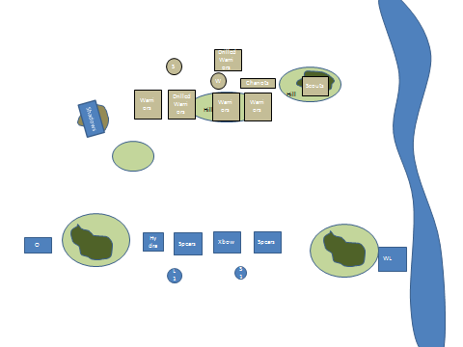

Turn 1
Lord Kulhaq won the right to commence moving first. As the Armies were deployed 60 cm apart, there was very little actual activity apart from moving forward, neither side deemed it wise to conduct any Marching Orders. The Dread Elf Shadows (absolutely love these guys, in the right circumstances they can prove to be a real threat), waited until the Beastkin Warriors to their front advanced before unleashing an accurate volley of Dread Elf bolts into the unfortunate beasts, causing 3 Wounds.
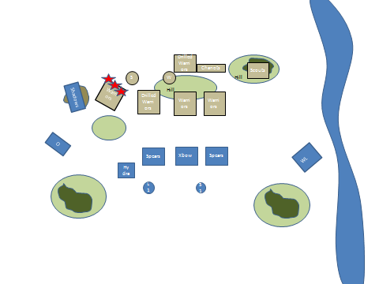
Turn 2
The Beastkin Army won the Initiative for the last time in this battle. The Beastkin Warriors who had suffered under the bolts of the Dread Elf Shadows continued their advance towards the Outriders in a vain attempt to keep their right flank free of Dread Elves. The Outriders sneered jubilantly, one Beastkin Formation had been dragged out of the battle line, they wheeled and advanced towards the exposed flank of the larger Formation of Drilled Beastkin. The Crossbows advanced, and under the influence of the Aim for the Heart Spell, killed several of the Drilled Beastkin. Lord Kulhaq had successfully seized the initiative and used the combination of spells from Zalizar and the power of the Dread Elf Crossbow to inflict death on the Drilled Beastkin, a very dangerous Formation. Elsewhere the Dread Elf Spears held their ground, the slow moving Hydra advanced, smelling blood and barely listening to the commands of its handlers. Maaahr realised that the Dread Elves would just shoot his tribe off the hill, he ordered an advance along the whole of his battle line. Only the Beastkin Scout remained hidden in the Woods, the Chariots advanced, baiting the War Lizards to advance even further toward them. The Beastkin Shaman, Rwagar managed to cast Barkskin on the Drilled Beastkin and continued to move away from the Shadows, he had no spells that could deal with them in one successful casting; and he knew that he would be a prime target for their deadly accurate bolts.

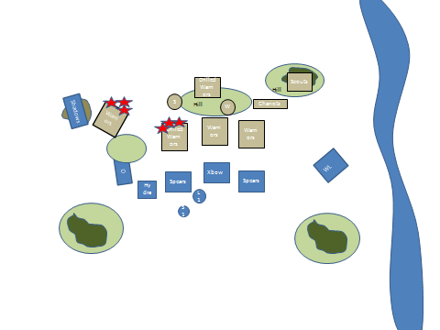

Turn 3
The Dread Elf Nobility and Knights seized the opportunity to charge the beastkin Chariots, they rode and rode hard, urging their War Lizards on with evil spikes and smashed vials of blood to increase their bestial fury. The Chariot riders were too slow witted to realise their fate, the Beastkin Scouts quailed at the sight of the enraged charging giant Lizards (they failed the test to charge a fear causing enemy) and stayed safe in the woods, abandoning the Chariots to their doom by themselves. The Elite of the Dark Elf Army smashed into the Chariots, piercing bodies, crushing ramshackle chariots and trampling others. The Chariots were completely destroyed, and the War Lizards plunged onwards, onwards into the rear of the Beastkin Army.
Meanwhile the Beastkin Warriors, harassed by the Shadow,s completed an about turn, desperately attempting to regain their position in the Battle Line, as they continued to suffer under volley after volley of wickedly accurate bolts; they left over a quarter of their comrades dead and dying behind them. The Dread Elf Crossbows sent another volley into the Drilled Beastkin, before they were charged by a Formation of Beastkin Warriors. The Drilled Beastkin were then charged by a Formation of Spears, the Hydra sensing death crashed into the Drilled Beastkin as well. The Outriders could not get a flank charge in just yet, they positioned themselves nervously, watching the Beastkin Warrior to their left rear. Maaahr brought his reserve Formation of Drilled Beastkin to support the Chariots. They looked on stunned as the Chariots were destroyed in a swift brutal charge. The last of the Beastkin Warriors charged the Spears to their front.
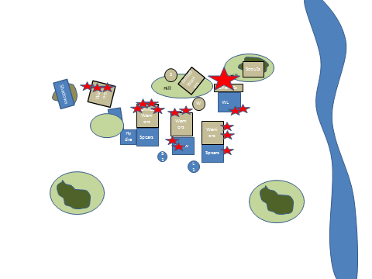
Turn 4
The Dread Elf Outriders flank charged the Drilled Beastkin, but they in turn were flank charged by the depleted Beastkin Formation, who only just made their charge. Combats become deadlier and brutal. Lord Kulhaq charged the leftmost Beastkin Warrior Formation and personally took 4 wounds from this unit. This Formation broke, fled and were destroyed as they ran away. Lord Kulhaq urged his Spears onward, sensing victory. The Beastkin Scouts had finally left the sanctuary of the Woods, only to observe the second Beastkin Army Formation destroyed before their eyes. The Dread Elf Crossbows lost their combat, but held their ground as their casualties mounted; many of them sensing that were now being used as bait until the rest of the Beastkin Army could be destroyed, but they held all the same. The Drilled Beastkin and Warriors beat the combined efforts of the Outriders, Hydra and Spears. They had suffered some horrendous casualties, but they were fighting back with a bestial fury. The Dread Elves all managed to hold, even the Hydra looked as though it would seek easier prey, but it was still consumed by a feeding frenzy, and continued to cut a bloody swathe through the Beastkin.
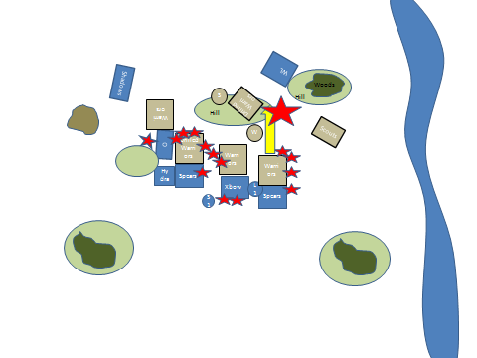
Turn 5
The Shadows again displayed their awesome combat abilities and charged the rear of the Beastkin Warriors, slaying many. This proved too much for the Beastkin, the Warriors and Drilled Beastkin both broke under this fresh onslaught, but there was nowhere to run to, they were all cut down to a beast. The War Lizards had reformed previously and now charged the Drilled Beastkin on the hill, the victorious Spears on the right flank now charged the exposed rear of these Drilled Beastkin. Despite the ensuing bloodbath, the Drilled Beastkin held, knowing that they would all either die in this battle or be cut down in attempt to flee with their miserable lives.
The Beastkin Scouts finally made an impact on the battle, charging the exposed flank of the Dread Elf Crossbows, who still managed to hold despite half of their number lying dead and dying. Even Zalizar was moving away from them, sensing that she would be exposed to these fouls beast with virtually no protection.
Maaahr bellowed an unintelligible challenge to Lord Kulhaq; who only sneered evilly with a raised eyebrow and an outstretched hand. Seconds passed as he watched the massive beast charge at him, his hand was still empty. “LANCE!” he roared as his new squire realised with terror he was supposed to react instantly to his Lords unspoken command, the lance duly appeared just before Lord Kulhaq leaned forward on his giant reptile mount and whispered “Death” and unleashed his War Lizard to commence its own charge to the rapidly approaching Warchief. With a mighty clash the two Generals crashed into each other, the personal retinues following with their own war cries and threats. The Hydra Hide Cloak saved Lord Kulhaq from the worst of Maaahrs fury, Maaahr was not so fortunate, his massive body had several deep cuts and many of his bodyguard had fallen to the silent but skilful retinue of Lord Kulhaq.
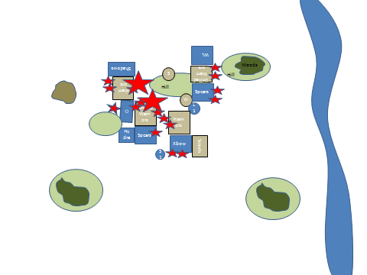
Turn 6
The Outriders now saw an opportunity for their own glory, and charged the Warchiefs embattled bodyguard. Even Lord Kulhaq had to admire the stubbornness of the Beastkin who were truly beaten but were refusing to break and flee, or surrender, they just kept fighting even with mounting casualties and knowing that they were totally surrounded. Against the odds, the Dread Elf Crossbows won their round of combat against the Warriors and Scouts.

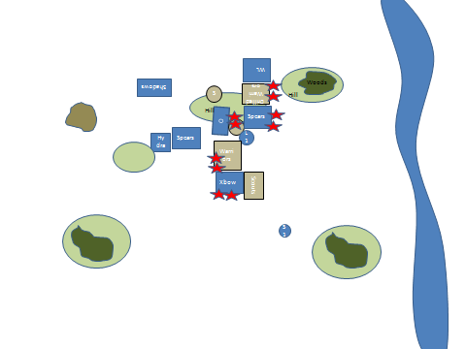
The sun began setting over the fallen, some of the Beastkin foolishly surrendered, some feigned death, many fought until their death, very few escaped at all. Maaahr, wounded, out of breath struggled to raise his massive two handed axe again, but Death pounced on him, the War Lizards foul breath almost overcoming him. Pinned to the ground he bellowed for a warriors death, but Lord Kulhaq was oblivious to his guttural moans. The Dread Elf General dismounted and calmly severed the Warchiefs left hand before delivering a concussive blow to Maaahrs head. “You are mine…slave” was the last thing Maaahr heard before passing out and falling into a violent nightmare of blinding pain in the stump at the end of his left arm; chains and burning sensations fuelled his nightmare…but the worst was yet to come.
Conclusion.
The Dread Elves had suffered many casualties, but they prevailed. Outnumbered in the combats by Beastkin Warriors with extra Ranks and Drilled Beastkin with better Armour (Armour Save 4+) and Exotic Weapons (large two handed axes mostly) the Spears and Crossbows held. I put this down to three things, deployment, higher leadership and getting the War Lizards to charge at the right moment. Having a higher movement rate also helped in running down fleeing Beastkin.
Deployment – by using the Scouting Ability of the Shadows, they were expertly placed to constantly harass one Formation of Beastkin Warriors, fully half of them died before they even get into combat. The Outriders also aided this, they teased the Beastkin Warrior out of their place in the battle line…but what else could the Warriors do? If they advanced the Outriders would have easily gotten into the rear of the Beastkin Army, if they attempted to charge down the Outriders, the right flank would have been exposed to the slower moving Hydra. It wasn’t until after they moved towards the Outriders that the Shadows commenced shooting them with bolts and they then realised their predicament. The Beastkin Scouts could have been deployed further forward, but by keeping them in line with the rest of the battle line could have been a nasty surprise, except that the War Lizards would not have fazed that much by their bow fire. If anything they would have been a speed bump if they tried to confront the War Lizards frontally.
Higher Leadership. With the exception of picking the deployment zone and gaining the initiative for one turn, the Dread Elves won all other Command Roll for going first. They even successfully seized the initiative to inflict some magically enhanced damage on the Beastkin with the Crossbow Formation. Their higher leadership also saw the outnumbered Dread Elves hold their ground the entire battle, even with mounting Demoralisation Markers, but some were very close rolls indeed.
War Lizards charging the chariots was a risk, I thought that they were close to their maximum charge range and considered the charge worthy of a gamble, they just reached the Chariots. Same with the Shadows with their rear flank charge, they had moved out of their cover and only just made their charge by 1cm, but it was worth it.

The Drilled Beastkin performed very well, Armour 4 is hard to get through! The Chariots will feature again, but I need to use them better. This came down to deployment, if they had been deployed opposite the Outriders, then their effect on the battle would have been very different.
Neither side got many spells off, some failed to cast, many were dispelled and sometimes there was no valid target. I think the Magical rules need to be given some attention, more spells, certainly more that can be cast into combat.
Blind Horizon and myself have come up with a couple of ideas on how magic works etc, so hopefully it should seem a little bit more of a struggle between opposing magic users to see who controls the magical forces when the casting of spells commences.
The rules do not address the issue of fleeing from combined frontal and flank/rear charges. Once the Beastkin Warriors failed their Command Test I decided that as they had the Shadows in their Rear Flank, they would be automatically destroyed. That seemed fair. I will polish up this part of the rules for consideration a little bit later.
I have also started to consider the introduction of artillery/war engines, but this may take a little bit longer to incorporate as the basic rules continue to evolve. Magic needs to be addressed first.
Overall the battle last 3 hours, again between two different opponents, this would probably come down to about 2 hours. With concealed deployment (ie the 2nd Drilled Beastkin Formation behind the hill) and the use of Scouts in cover, a GamesMaster/Umpire could be a good thing to have to instill that feeling that something could be in that woods over there, but is there? A surprise attack or ambush is hard to simulate if you can see the enemy models deployed in concealing terrain.

