4 Wartorn Beta Rules Battle Report 1500 points, Dread Elves versus Undead
In my fourth game of the Wartorn Rules I used a Dread Elf army versus a horde of Undead at 1500 points. The rules had been changed in a number of ways:

- Stands were replaced by Ranks, each Rank was now worth 2 Stands; the points value of extra ranks was substantially lowered. Most Core Formations start with 3 Ranks, Veteran 2 Ranks and Elites usually 1-2 Ranks. Monsters stayed pretty much the same as single Stands. With the exception of single Monsters and all Characters, all Ranks were now 80mm x 20mm. The Health of each Rank was therefore increased; this had several effects, Combats lasted slightly longer, Formations were cheaper to buy, Characters became very important in lending their increased Command Value to keeping Formations in the fight.
- There were some rules changes, mainly with Basic and Advanced Commands. If a Character was unable to issue an Advanced Command, then the Leader of the Formation could try again to get the order through. (Changed after the battle to a Failed Advanced Command meant that only a Basic Command could be issued).
- I tweaked the Scouts and Skirmisher rules (sorry Blind Horizon, I like my elite Scouts and Veteran Outriders to be able to shoot from all ranks due to their dispersed and fluid formations). I hope this stays in the rules, we shall see.
- The Animate the Dead Spell was re-written to only allow Necromancers replace lost Health/Ranks, not increase an Undead Formation beyond its starting strength, but the spell could be cast whilst the target Formation was locked in melee.
- Spells became cheaper to purchase.
The Armies
The Dread Elves (1524 points)
Lord Kulhaq, Dread Elf General Mounted on his War Lizard, armed with a Magical Exotic Weapon and a Hydra Hide Cloak @ 59 points
Kapitan Myzakil, Dread Elf Lord Mounted on his War Lizard, armed with a Magical Exotic Weapon and a Hydra Hide Cloak @ 59 points
Zalizar, a Dread Elf Sorceress with her own Hydra Hide Cloak, retinue of Guards, Acolytes; with the following spells, Aim for the Heart, the Dreaded Terror and Shatter Soul @ 89 points
Zalsmushi, a young Dread Elf Sorceress with her own Hydra Hide Cloak and knowing the Aim for the Heart, Darkness and Shatter Soul spells, @89 points.
5 x Formations of Dread Elf Spears, each of 5 Ranks @ 111 points each
2 x Formations of Dread Elf Crossbows, each of 3 Ranks @ 85 points each
A Formation of Dread Elf Outriders, of 2 Ranks @ 78 points
One Formation of Dread Elf Shadows, of 2 Ranks @ 85 points
2 x Formations of War Lizard Knights, each of 3 Ranks @ 96 points each
1 x Hydra @ 69 points
1 x Formation of Glaive Warriors of 2 Ranks @79 points (which I forgot to deploy!!!)

The Undead (1508 points)
Vampire Lord armed with a magical Exotic Weapon and an Invulnerable Save @ 63 points
Vampire Lord armed with a magical Exotic Weapon and an Invulnerable Save @ 63 points
Necromancer 1, with an Invulnerable Save and the following Spells, Decay, Nightmare and Animate Dead @ 85 points
Necromancer 2, with an Invulnerable Save and the following Spells, Wither, Decay and Animate Dead @ 85 points
4 x Formations of Spear Armed Skeletons, with 5 Ranks @ 84 points each
2 x Formations of Spear Armed Skeletons, with 3 Ranks @ 66 points each
3 x Formation of Skeleton Archers, with 5 Ranks @ 88 points
2 x Formations of Wight Infantry, each with 4 Ranks @ 103 points each
2 x Formations of Wight Cavalry, with 3 Ranks @ 97 points each
2 x Stands of Undead Chariots @ 80 points

Deployment
Please note that the size of the formations are not displayed to exact scale and size, they give a close approximation of their position and facing. As Ranks were destroyed, although actually removed during the battle, I did not reduce the size of the Formations (I got lazy putting the map together).
The Dread Elves won the Command Roll to choose which table edge to deploy from, who would commence deploying first and who would get the first turn. Noting the large number of Undead Formations the Dread Elves forced the Undead to deploy in the smaller southern deployment zone and to begin deploying first.
The Dread Elves had hoped to hold the centre of the battlefield with their mixed Spear and Crossbow Formations, use the Spears on their Left Flank to hit the Undead Right Flank. They deployed their War Lizards to hold off the Wight Cavalry and Chariots.
The Undead were not able to deploy their full strength forward and had to deploy deep, but held their deadly Wight Infantry in Reserve along with the 2 smaller Spear Formations, ready to plug any gaps in the battle line. Concentrating their mounted Formations on their Left Flank to bait the War Lizards forward and flank charge with the Undead Chariots later.
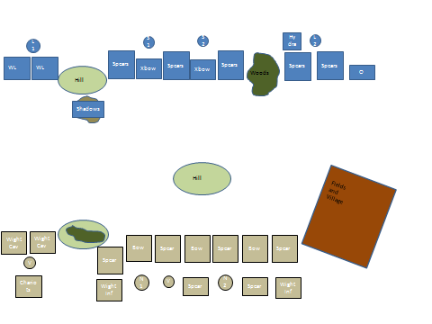
Turn 1
The Dread Elves forced the Undead to commence moving first, the Undead Horde shambled forward in a solid wall of skeletal legions. The Dark Elves issued orders to March Move, but several Formations did not obey these commands, notably the Spears.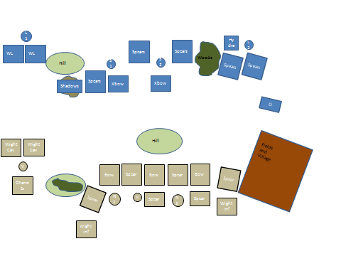

Turn 2
The Dread Elves managed to get their Spear Formations moving forward as the Undead Horde continued its gradual advance to the Living. Lord Kulhaq could not get his rebellious Knights and their bestial mounts to move forward against the wall of Undeath approaching them.
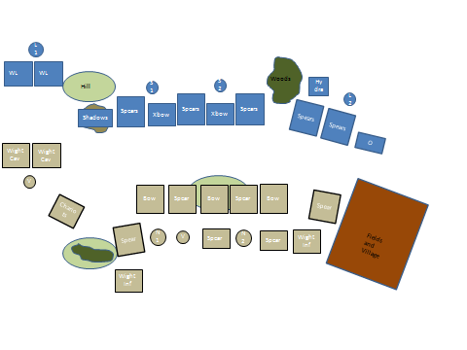

Turn 3
Dispatching all of his messengers forward, Lord Kulhaq successfully ordered both Formations of War Lizard Knights to Charge the Wight Cavalry. The Wights took horrendous casualties, but the presence of a Vampire Lord, who had conducted his own counter-charge, kept both Formations of Wight Cavalry in the fight. The Undead continued to relentlessly advance and took several casualties as the Dread Elves finally commenced using their Crossbows to devastating effect. Lord Kulhaq moved towards the centre of the battlefield to inspire the troops there and hold the centre. The Outriders, using their Skirmishing ability moved freely through the human fields and commenced shooting the Undead Spears to their front, returning many of them to the arms of Death himself. The Necromancers and Sorceresses’ were evenly matched as Spells were cast and subsequently Dispelled.

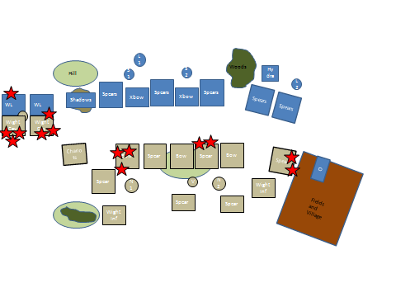
Turn 4
The Dread Elves noted the ability of the Undead to absorb mass casualties and remain in the fight, orders for all Dread Elves to Charge was given and carried out! The Sorceresses managed to only 1 Spell to get through the Magical Defences of the Necromancers, who in turn concentrated in reanimating their Undead Legions, getting the recently killed Skeletons back into the Ranks. A Flank Charge by the Outriders, whilst devastating to a Living Unit was absorbed by the Uundead ability to ignore casualties. The Wight Cavalry began to inflict more casualties on their Dread Elf counterparts, mainly due to the presence of the Vampire Lord.
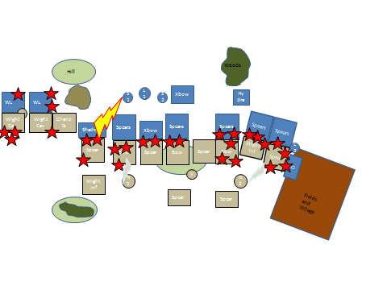
Turns 5 – 6
With the vast majority of Formations in melee the Sorceresses’ moved into positions ready to pick off any exposed targets, none of their Spells could be cast into melee. The second Vampire Lord fled from Combat but was able to rally and charge back in on Turn 8. The Wight Cavalry continued to grind down their War Lizard counterparts, who managed to hold each turn despite the mounting Demoralization markers they were receiving as a consequence of losing combats.
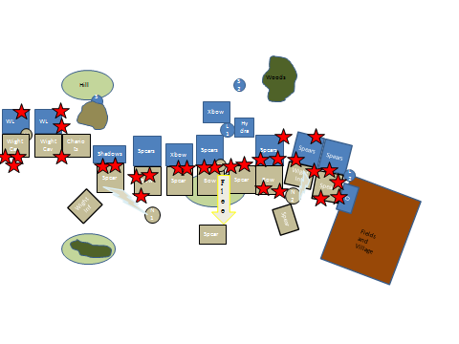
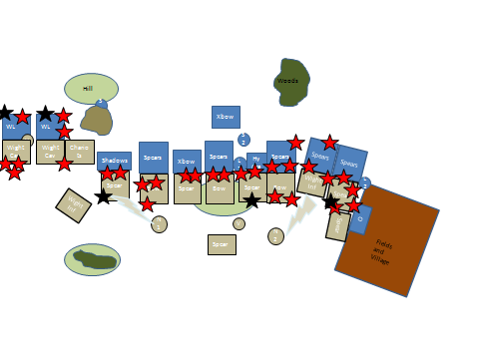
The War Lizards were finally ridden down and destroyed, as were several Undead Formations, as the Hydra made its presence felt. The Necromancers began concentrating on reanimating the Wights, but with little success. The Wights, especially the Infantry, made their mark, but the Spear armed Skeletons finally succumbed to Death as the Dread Elves held and continued to cut them down. The Dread Elf Shadows proved their worth and despatched a Formation of depleted Undead Spears.
Turn 7
The Outriders finally fell to the Spears, but their sacrifice had allowed the Dread Elf Left Flank to destroy the Undead Formations there. The second Vampire Lord fled for a second time but was cut down. The Shadows Flank Charged the Undead Chariots as the Wight Cavalry regrouped.
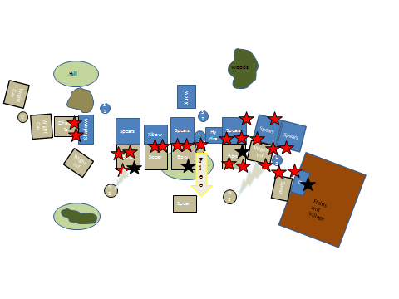
Turn 8
The carnage continued as the Dread Elves continued to return Skeletons to Death. Both Sorceresses took a chance and moved forward, killing their opposite Necromancer. The unengaged Dread Elf Spears and Crossbows changed their facing ready to receive the inevitable charge of the Wight Cavalry. The Shadows destroyed an Undead Chariot Stand, whilst the Wight Infantry on the Undead right flank suffered many casualties as they now faced a third Dread Elf Spear Formation. The last remaining Undead Spear Formation managed to Charge the depleted Dread Elf Spears to their front.
With both Necromancers dead, the remaining Undead Infantry Formations down to their last Ranks whilst most of the Dread Elf Formations had at least 2-3 Ranks each, the Undead conceded defeat.
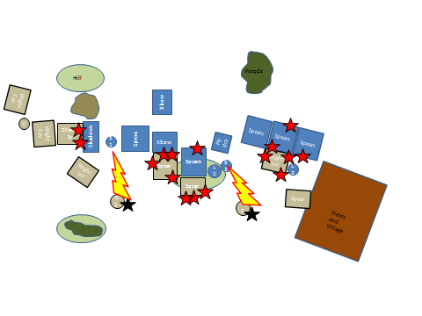
After Action Review
This battle was played whilst I was sick with the flu, which I blame for not deploying the Dread Elf Glaive Warriors!
Although it may look like the armies were unevenly matched at the end of the battle, the Dread Elves managed to pass the vast majority of their Command Tests after losing a round of combat; both of the War Lizard Knight Formations and one Spear Formation had 3 Demoralisation Markers on them, the War Lizards both failed their 4th test, the Spears won their next Combat and therefore had their 3 Demoralisation markers removed.
The use of the Outriders to outflank the Undead was classic, as was the use of the Shadows to shoot at the approaching Undead Spears before Charging them.
The Undead were hampered by their deployment zone; placing their Wight Infantry in the front battle line would have been a better deployment option. Wight Infantry are rock hard with a high Health and Heavy Armour and Exotic Weapons. Although they are listed as a Core Formation, I think their numbers should be restricted to being 1 Wight Infantry for at least 2 other Core Formation choices. The Wight Cavalry and Chariots could have been deployed on the extreme right flank with a Vampire Lord, but this would have meant they would require at least 4 turns to have hooked around the Dread Elf left flank.
The Dread Elves gambled a little and Charged into combat, nullifying the outnumbering Undead Archery. The Dread Elves were winning most of the combats, but the Necromancers continued to Re Animate the recently killed Skeletons back into combat. The Dread Elves were losing more Ranks than the Undead during several turns. The loss of both Necromancers and one of the Vampire Lords had an immediate effect on the flow of the battle. This was another risky move, as both Sorceresses had placed themselves in a position to have been easily killed themselves by their targets if the Necromancers did not die first, it was also a risk in Seizing the Initiative to get the second Sorceress to move and kill the second Necromancer. The Sorceresses were free to commence blasting the Undead after this, no more Skeletons would arise again to fill the depleted Ranks; with no high Command Value, even the Wights began to take extra casualties from lost combats.
With the change in the number of points per Formation this certainly turned out to be a huge battle. The Undead could have done with at least one more Character, possibly 2; one each of Vampire Lord and Necromancer.
The battlefield was about 6 feet by 4 feet, the human fields and village occupied roughly a quarter of the Undead deployment zone. This was a very good decision by the Dread Elves to force the Undead into this deployment zone. It certainly stopped the outnumbered Dread Elves being flanked easily.
With the increased number of Formations on the table, the rules handled this quite well. Archery did not achieve much, as the Dread Elves thought it a better idea to engage the Undead centre instead of having Undead Archers kill them at range.

